REPATRIATION TO CAMBODIA
This pamphlet has been prepared to provide information to individuals who are detained and who have been ordered deported by the Immigration Judge.

- One-on-one Reality-Based Counseling

Phaly Sir, MSW
Cambodian Case Manager and Counselor
4301 S Pine St. Suite 456
Tacoma, WA 98409
Phone: (253) 697-8606
E-mail: phaly.sir@goodsamhealth.org

- Humanitarian Organization in Cambodia

The Returnee Integration Support Center is a non-governmental humanitarian organization facilitating the integration into Cambodian society of people who were admitted to the United States as refugees and are being deported to Cambodia. They provide assistance with documentation, employment, housing and referral services, in order to support returnees who seek assistance in becoming independent and productive members of society.

Returnee Integration Support Center
Phnom Penh, Cambodia
Mr. Aun Kleong
Program Manager
E-mail: info@risccambodia.org
Phone: 855-11-736-123

RISC created a “survival guide” for returnees, which is reproduced inside this pamphlet, with some additions from NWIRP and other volunteers.

- Legal Assistance at the Northwest Detention Center

The Northwest Immigrant Rights Project (NWIRP) provides legal assistance to detainees who do not have lawyers through the Legal Orientation Program.

Northwest Immigrant Rights Project
253-383-0519
877-814-6444

SURVIVAL GUIDE
How are you going to survive in Cambodia? The answer is entirely in your hands. This guide will give you some basic information and suggestions on how to manage your entry and integration into contemporary Cambodia. You may need to make some adjustments in your expectations and lifestyle – and we don’t mean to make light of these as some will be traumatic to you and others - but you will survive. Scores of returnees have preceded you and help is available. You will not be alone.

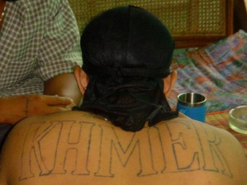

A returnee relaxes with friends at home.

What can I do to prepare myself for the future?

If you face deportation, one of the hardest parts of the process will be the uncertainty. There is no way to know when your case will move. Some returnees were already in custody prior to deportation but others were picked up from their homes or jobs without notice.

- Save money for your future. Whatever happens, having access to a little extra cash won’t hurt. If you are deported, a few thousand dollars could go a long way toward getting you set up in a little business.

- Consider setting up a “power of attorney” so some trusted friend or relative could manage any legal affairs if you are suddenly detained for deportation. A power of attorney would permit someone you designate to dispose of any property you own (car, motorbike, etc.), gain access to any bank accounts you have so the money could be transferred to you and handle any other outstanding legal matters according to your instructions. A power of attorney agreement can be quite narrow and specific (e.g. authorizing the disposition of a vehicle) or quite general. You and your legal advisor should carefully decide what is best for you, but the documents should be written up, signed, notarized and put away in a safe place long before they are needed.

- You should also consider developing skills that might be in demand in Cambodia. For example, certification as a barber, mechanic, electrician, plumber or computer repairman or experience as a web site designer, database programmer, audio-visual technician, cook, waiter, receptionist or telephone operator would make you more marketable than experience as a fork lift operator or work on an assembly line.

- If you have a good basic education and have good language skills, consider getting a certificate in the Teaching of English as a Foreign Language (TOEFL) or accounting or bookkeeping. There are always jobs available for people with those qualifications – especially those who are also bilingual.

- Brush up on your Khmer language skills (both oral and written). Many Cambodian-American communities have Khmer language classes available or you can use free online Khmer language materials (see Study Khmer Online on the Orientation Materials page of the RISP web site). You can also listen to Khmer language broadcasts over the Internet.

- If you already read and write Khmer, you might want to improve your vocabulary by going to the Internet and reading contemporary Khmer newspapers and magazines. Good translators and interpreters are always in demand and are well paid.

Is it true that the US government (or the Cambodian government or some other agency) gives each returnee some amount of money for resettlement costs?

No, that isn’t true. No cash is given to returnees by either government or any other agency. Funds made available for resettlement assistance can only be used to provide needed services. These funds cannot be used for cash payments to returnees.

What should I carry with me to Cambodia?

- At least US$20 but not more than $100, enough to cover phone calls and incidentals, but not enough to appear wealthy. The money you saved in the States can safely be transferred to you after you are settled in Cambodia. NOTE: Cambodian police will most likely go through your pockets, luggage and belonging and take everything from you.

- Photocopies ONLY of documents (certificates, diplomas, driver’s licenses, etc.). US authorities may take away originals. Have originals sent to you later.

- Addresses and phone numbers of friends and family in Cambodia. Before leaving the U.S., try to establish contact with people in Cambodia who might be able to assist you in your transition.

- E-mail addresses of friends and family in the U.S. You will have access to the Internet and it is a fast and relatively inexpensive way to communicate.

How will I actually get to Cambodia?

Those being deported to Cambodia are usually gathered at a holding facility in the western or southwestern US. Groups being deported to Cambodia usually consist of 12 to 15 individuals.

You will travel to Cambodia on a charted commercial jet. Deportees are accompanied by US Marshals including a medical officer. You will be restrained in flexible (nylon) handcuffs during flight and will not have access to any personal belongings. You will be required to speak only in English. Recent groups of Cambodian deportees have been flown to the Philippines with deportees to that country, then on to Cambodia. The flights are long and boring but otherwise unexceptional.

What happens on arrival?

When you arrive at the airport in Phnom Penh, you will be met by officials from the Cambodian Immigration Department. There will be heavily armed security personnel in the area but this is routine at an international airport – no reason to be nervous, it isn’t for your benefit.

You will be taken to stay in the Immigration Department compound directly across the street from the airport where the Cambodian government processes your paperwork. There is a dormitory in the compound where you will be required to stay until your paperwork is completed. Some groups have been detained at the Immigration compound for several weeks but recent groups have only remained for one to three days.

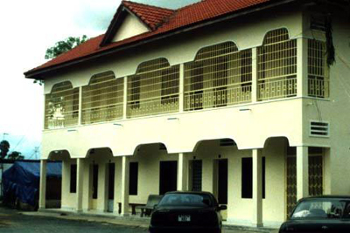

Cambodian Immigration Department Dormitory

What are the conditions at the Immigration Department compound?

- You will receive humane treatment.

- You will be able to receive visitors, both family members and advocates who are committed to helping you through the repatriation process.

- Staff from the Returnee Integration Support Center (RISC) will be permitted to visit you in the Immigration Department compound. Returnees, like yourself, working for RISC, will be able to meet and talk with you in order to provide support, answer questions and give advice. However, RISC has no authority inside the compound. Staff will enter as guests of the Cambodian authorities and will conduct themselves accordingly.

- The food served is Cambodian and is in adequate supply.

- Regardless of what you may hear, the guards and officials with whom you will have routine contact at the Immigration Department compound have no authority to determine the time of your release. Please keep this in mind.

- Be prepared for boredom and uncertainty while you are staying in the compound. If you are there more than a day or two, you will almost certainly have the opportunity to play sports, walk around inside the compound, receive visitors, etc.

What happens when I am released from the Cambodian Immigration compound?

- Release to sponsor/family. The Immigration Department attempts to arrange for each returnee to be released to a “sponsor” - usually a friend or relative. Sponsorship entails no legal or financial obligations. It is essentially an acknowledgement that the returnee was properly released by authorities.

- If no friend or relative is available, RISP may be able to sponsor you.
- There are no fees involved in sponsorship or in the processing of entry documents.

What sort of identification documents will I have?

The Cambodian government will issue you with a document attesting to your citizenship. This document is the basis for all future documents you may require (family book registration, national ID, driver’s license, voter’s registration, passport, etc.). The document gives no information about any past criminal record in the US but does state that you were repatriated to Cambodia, so it is best to quickly obtain neutral ID which will be more useful in opening a bank account, applying for a job or renting housing, etc. RISP can help you secure needed documents.

Is it true that returnees are discriminated against by local Cambodians?

- No. Returnees who make the effort to blend into Khmer communities are usually accepted with warmth and respect.

- Returnees who marry here are often regarded as the virtual head of their extended family because of their fluency in English and the fact that they have had experience outside Cambodia.

- Most Cambodians won’t know or care you have been deported unless you tell them or demonstrate by your dress and demeanor that you don’t belong and don’t want to belong here.

- Having a felony conviction may make it difficult to find certain types of jobs (as would be true anywhere).

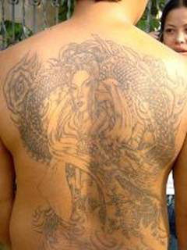

This returnee is proud of his elaborate tattoos.
He is also proud of his good job as a manager in a small business.

I have tattoos – won’t this be a problem for me?

- Tattoos are not unusual in Cambodia. Deputy Prime Minister and Co-Minister of National Defense Gen. Nhek Bun Chhay is proud of his tats as are a great many Cambodians. Traditional tattoos having religious significance are most common but younger people are seen with more decorative tats.

- Tattoos which are gang / violence / drug related in nature, or otherwise culturally inappropriate, should be kept covered in public. As Cambodian men keep their shirts on in public unless they are engaged in manual labor or sports, there is not much public display of tattoos and, therefore, not much of an issue. One returnee got a job as a pool attendant at a five-star hotel. When his supervisor saw his tattoos, he was reassigned to a new position where he could wear a shirt (but he was not fired).

- If you have tattoos on your face, neck or hands you may be excluded from some types of jobs as would be true anywhere.

How can I communicate with my family and friends in the US?

If you don’t have one already, set up an email account (e.g Gmail or Hotmail) and learn how to use it. You will have access to the Internet in Cambodia.

What should I wear in Cambodia?

In the cities, people generally wear Western-style clothing. At home, men and women often wear sarongs. Men wear shirts unless they are at home or involved in manual labor or sports. A man appearing in public without a proper shirt (at least short sleeves) will instantly be regarded as odd – even threatening. – and may be viewed with disgust or contempt.

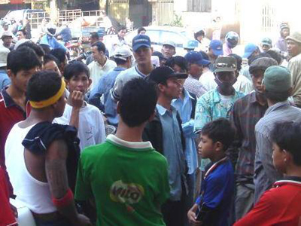

A returnee (left) is confronted by an angry crowd after he was involved in a minor traffic accident. Because of his style of dress, his tattoos and demeanor, the crowd believed he was a Thai thug. Police in the area did not respond to calls for assistance. Eventually the crowd dispersed but it was a tense time. Note the dress of all others in the photo.

The wearing of shorts, tank tops, baseball caps turned sideways, doo rags, flashy jewelry, etc., in public situations will identify you as odd. The same goes for loud, aggressive, culturally inappropriate behavior. As a direct result of the way you present yourself, you may be charged higher prices, treated rudely, denied service or worse. If you wish to be treated with dignity and respect, adjust your dress and demeanor accordingly. Buy your clothes locally.

Using the traditional greeting along with proper speech and dress will help you ease into your new life in Cambodia.

How can I speed up my integration process?

The customary form of greeting is the sompiah, and involves pressing the palms together and bowing. If you aren’t already familiar with this, watch carefully how it is done and learn to do it easily and gracefully. Combined with proper dress and polite speech (even if your Khmer is fairly basic) the appropriate use of the sompiah will go a long way toward winning acceptance among your fellow Cambodians. Failure to show respect will instantly identify you as odd or ill-intentioned.

What if I have asthma or diabetes or HIV or some other chronic physical or psychological condition?

Medications and treatment are available but it is important that you alert RISP staff to your condition as soon as possible. Even if you are sponsored by family or friends, RISP will be happy to see that you and your sponsor know what services are available and how to take advantage of them.

Climate

Cambodia has a tropical monsoon climate with two seasons. The dry season takes place from November to February. In the rainy season between May and October, prepare for high humidity and daily, afternoon showers. Beginning at the end of July and continuing through November, flash flooding can occur throughout the country, disrupting roads, bridges and transportation. Travel to rural areas becomes extremely difficult, if not impossible.

Average temperature range: 70 to 95F (21 to 35C). April is hottest month, with temperatures climbing up to 105F (40C)!

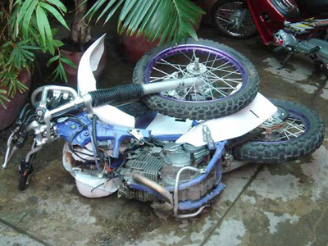

Two returnees survived this crash which broke the bike in two.

What about traffic?
Your first reaction to traffic in Phnom Penh will be that it is chaotic. In fact, there is an internal logic to it, but it is quite different to traffic in the States and it will take you some time to adjust to the flow. You should spend some time watching traffic from the back of a motorbike before you venture out on your own. Attempting to negotiate Phnom Penh traffic while under the influence of alcohol or drugs is dangerous in the extreme – both to you and others.

I am Cambodian, but I don’t really know much about Cambodian culture. What is “culture shock” and should I worry about that?

You need to prepare yourself for a big adjustment in the way you relate to people and the way they relate to you. Be careful, take it slowly, watch, listen and learn. Adjust your dress, language and demeanour to blend in with your surroundings. You will encounter actions and attitudes you may regard as superstitious, unreasonable or just weird. Many Cambodians have great respect for the supernatural (ghosts, witches, fortune tellers, faith healers, magicians, dreams, numerology, astrology, etc.) Try not to be judgemental. Cambodians are survivors. Along with your grandparents, your parents - and you - they have survived some of the most cataclysmic events imaginable and they have come to rely on instincts, beliefs and strategies they believe have worked for them. If your Khmer girlfriend gets a new phone, then insists on buying a phone number ending in seven because she was born on a Tuesday . . . help her find one.

The experience of “culture shock” (or cultural disorientation) is usually experienced in four fairly distinct stages:

- Enchantment. This is the “honeymoon period” when so many things seem interesting and exciting. There is a sense of adventure and exhilaration.

- Disenchantment. After a few months, a sense of reality sets in and difficulties in adjustment or finding employment begin to mount. Feelings of longing for family and friends in the States may cause mild or severe depression.

- Retreat. Some returnees slip into heavy alcohol or drugs use or literally retreat into a bedroom or a bar and try to limit their contact with the real Cambodia. They stop looking for jobs or quit jobs they have and break off relations with friends.

- Adjustment. Over time, most returnees settle into positive, supportive relationships, find employment, adjust to the culture and climate and start new lives here. It is not at all unusual to hear returnees who have been here for two or three years say they would not return to live in the States if they could.

For more information about this, see the Orientation Materials page on the RISP web site for the link to “Cultural Disorientation and Transitional Adjustment” by Robert Kohls.

Reverse culture shock – returning to one’s own culture after being gone for some time – also has its unique challenges. You may expect to be able to fit in quickly or you may choose not to fit in or the people around you may be confused that you look Khmer but don’t act or sound Khmer. You may be regarded as an overseas (i.e. rich) Khmer here for a brief visit rather than a new member of the community. Crossing your legs in a certain way or stating your opinion too directly may be regarded as offensive when the same action by a foreign resident would be quite acceptable because, as a Khmer, it is assumed you should know better.

In some cases, you can actively prepare for the transition (e.g. study Khmer language and culture). In other cases it may simply be helpful to understand what is happening inside your own mind, to know that it is not unusual and to deal with these challenges as intentionally and creatively as possible. Help is available.

Customs & Culture

- Clothing: Casual dress is OK, but typical gang attire or very casual attire will invite negative attention and can cause problems. In short, keep your shirt on (whether you have tattoos or not).

- Shoes: Remove shoes before entering homes or temples.

- Bargaining: Common in street stalls, markets, with cyclos and motorbike-taxis. Learn to bargain with cheerful confidence and be prepared to walk away – several times – until you settle on a fair price.

- Toilets: Squat toilets are standard but western toilets are increasingly common.

Always be respectful of elderly people and people in authority. Show respect in the way you greet them and the way you stand, sit and speak.

Show respect for Buddhist monks, temples, images and statues and members of the Royal family (including their images on display in most public buildings and many private homes). This is extremely important. Any slight – intended or not – against a symbol of the Buddha or the Royal family would be regarded as offensive to all Cambodians.

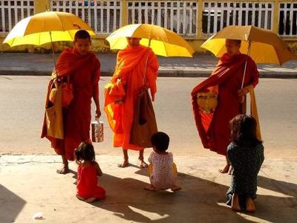

Monks making their daily rounds giving the faithful the
opportunity to make merit by giving small offerings of food or money. Each monk is a symbol of the Buddha and should be treated with reverence.

Behavior acceptable in the US may not be acceptable in Cambodia. Loud talk or actions perceived to be obnoxious, aggressive, rude or insulting could provoke violent reaction from locals - including armed security personnel. There have been several incidents in which returnees were beaten up as the result of a misunderstood look or gesture.

The carrying of unlicensed weapons is illegal. There are police checkpoints where random checks are done. If weapons are discovered, this will result in a fine and/or imprisonment. Security forces are authorized to use lethal force against anyone attempting to flee a checkpoint – and do.

Dates are given in the order day + month + year. September 27, 1978 is written as 27/09/78. April 3, 1978 is written 03/04/78.

Cambodian names are given in the order family name + given name.

Khmer is the official language and some older people speak French, but English is Cambodia’s second language. Cambodians are often eager to practice English with anyone who speaks it and many returnees teach conversational English formally or informally.

Is the water safe to drink?

Tap water is not safe to drink. Bottled water is easily and cheaply available (less than US$0.15 for 20 liters – more than 5 gallons).

What about the food?

The standard diet consists of rice, fish and vegetables but Cambodians love to eat all kinds of food at all hours of the day and night. Vendors selling fruit, sweets, bread and all sorts of snacks wander through the markets and around the streets attracting little clusters of school children, office workers and moto drivers all over town.

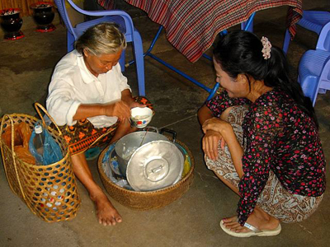

Vendors wander the streets bringing fresh meals
and snacks right to your door throughout the day.

